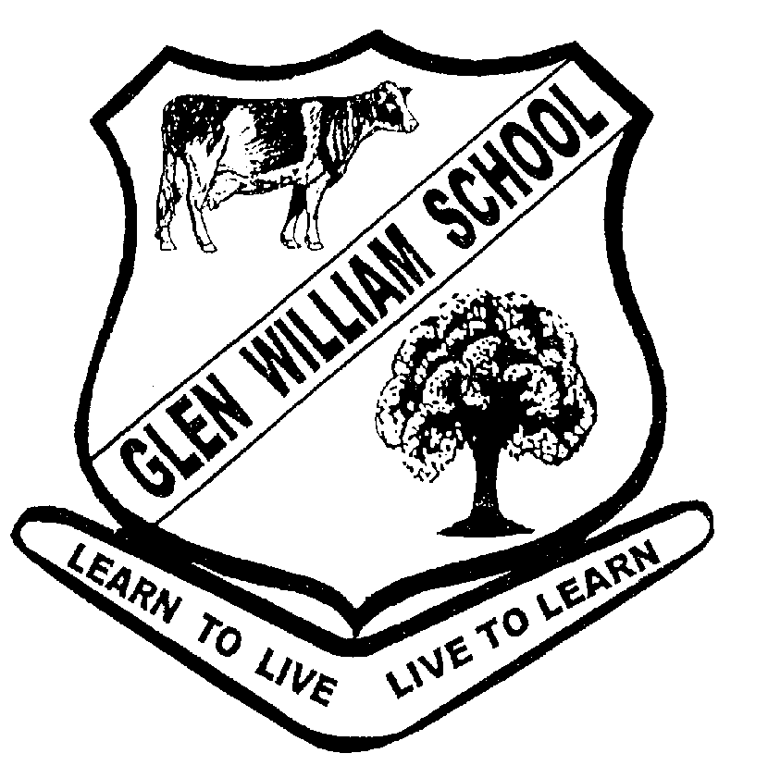

Glen William Public School
Established 1849

717 Glen William Road
Glen William NSW 2321
Phone: 49965507 Fax: 49965541 Email: glenwillia-p.school@det.nsw.edu.au
Website: www.glenwillia-p.school@det.nsw.edu.au
Principal – Mrs Kristy Bultitude

18/10/2016
Engraved Paver Fundraiser

If you would like to order a brick, please complete the below order form. Orders will be filled when we have a suitable number to reduce delivery costs.

Cost: $30

-------------------------------------------------------------------------------------------------------------------------------

Name ______________________________

Paver Type | Quantity | Cost

Hand Drawn 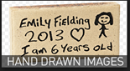 Name Paver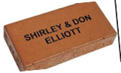

If you are interested in purchasing a hand drawn paver, please complete the drawing on the attached page and send in with your order.

Signature Date

Hand drawn paver template

Name____________________________________

